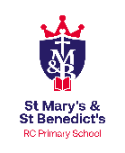
English Curriculum Map

Year: Reception Class: Beesley Year: 2023-2024

 | Autumn 1 | Autumn 2 | Spring 1 | Spring 2 | Summer 1 | Summer 2
Timescale | 7 weeks | 8 weeks | 5 weeks | 5 weeks 4 days | 5 weeks 4 days | 7 weeks
Topic | Marvelous Me! | Seasonal Celebrations | Brilliant bears! | Roots, shoots and muddy boots | All creatures great and small | Transport and Travel
Focus Texts  (picture/bk/author) | The Colour monster  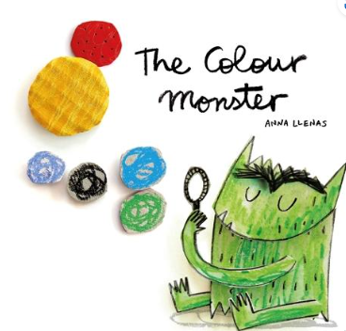  Ruby’s Worry  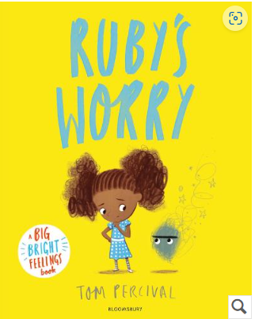  Once there were giants  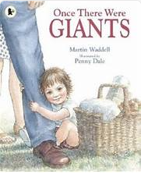  The smartest giant in town  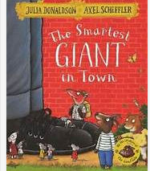 | Little Glow  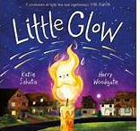  Peppa’s Diwali  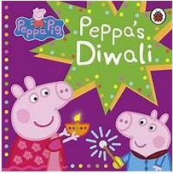  Sam’s Snowflake  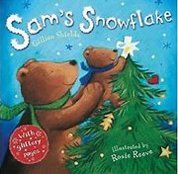 | We’re going on a bear hunt….  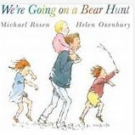  Brown Bear, Brown bear what do you see?  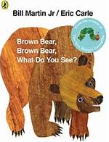  Polar bear, Polar bear what do you hear?  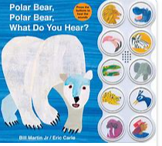  Goldilocks and the three bears  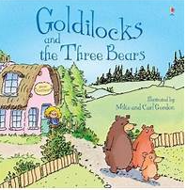  Peppa’s Chinese New Year  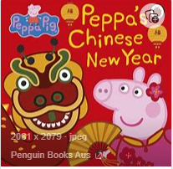  Non- Fiction Texts- Bears | The Three Little Pigs  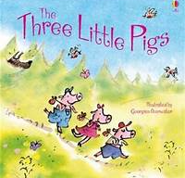  The Enormous Turnip  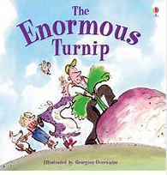  A squash and a squeeze  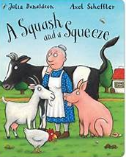  Little Red Hen  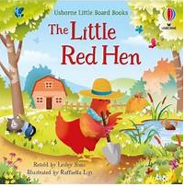  The Scarecrow Wedding  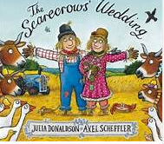  Non- Fiction: Baby animals | Harry and his bucketful of  Dinosaurs  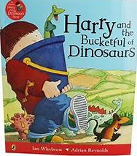  The very busy spider  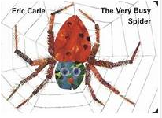  Shark in the park  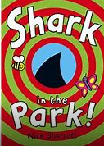  Elmer  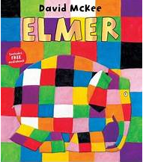  How many legs?  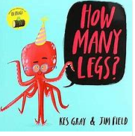 | Whatever Next!  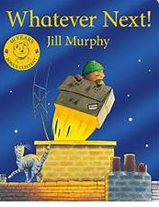  Bob the man on the moon.  The way back home.  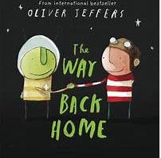  The Naughty Bus  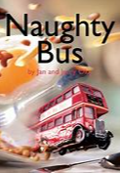  Mr Gumpy’s Outing  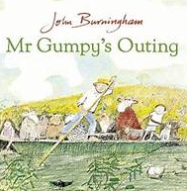  All aboard for the Bobo Road  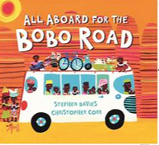
Enrichment/visits/  Authors etc | Baseline assessment weeks 1-4 | Bonfire Night 5th November 2023  Diwali 13th November 2023  World Nursery Rhyme Week 13-17th November 2024 | Winnie the Pooh Day 18th January 2024  Chinese New Year 10th February 2024 | Farm visit- Smith hills- TBC  National Tell a Fairy Tale Day  26th February 2024  World book Day 7th March 2024 | Elmer’s Birthday 27th May 2024 | Transition afternoon
Literacy Focus | Begin phase 2 phonics (Red Rose Scheme)  Discrimination of sounds developing phonological awareness  Recognise words that have the same initial sounds.  Give meaning to the marks they make.  Write some letters in their name  Fine motor- pencil control  Listen to stories and retell | Continue phase 2 phonics  Write some letters accurately.  Developing phonological awareness recognize words with the same initial sounds  Writing initial sounds and basic CVC labels  Retell stories through small world and role play  Read individual letters by saying the sounds of them  Understand that print has meaning, and we read English from left to right  Write some or all of their name | Phase 2/ 3 phonics  Write some letters accurately.  Initial sounds and CVC labels (extend to captions)  Sequence and retell stories  Write some or all of their name  Read individual letters by saying the sounds of them  Describe events in familiar stories and predict events (join in)  Blend sounds in words so they can read short words.  Be able to name different parts of a book | Phase 3 phonics  Read simple phrases and sentences.  Write labels and captions  Begin to write words by segmenting the sounds in words  Form lower-case letters correctly | Phase 3/ 4 phonics  Read captions and sentences  Use and understand new vocabulary from stories, poems and non fiction  Discuss what they know/ have found out  Draw vocabulary and knowledge from non-fiction and use throughout the day in different contexts  Form capital letters correctly  Begin to write short sentences with words with known letter-sound correspondences using a capital letter and full stop,  Read a few common exception words in line with Red Rose Phonics | Phase 4 phonics  Read aloud simple sentences including some common exception words  Write simple sentences-including finger spaces, capital letter, full stops  Use and understand new vocabulary from songs and stories  Sequence and retell stories  Re-read what they have written to check it makes sense  Anticipate key events in stories

