Good News
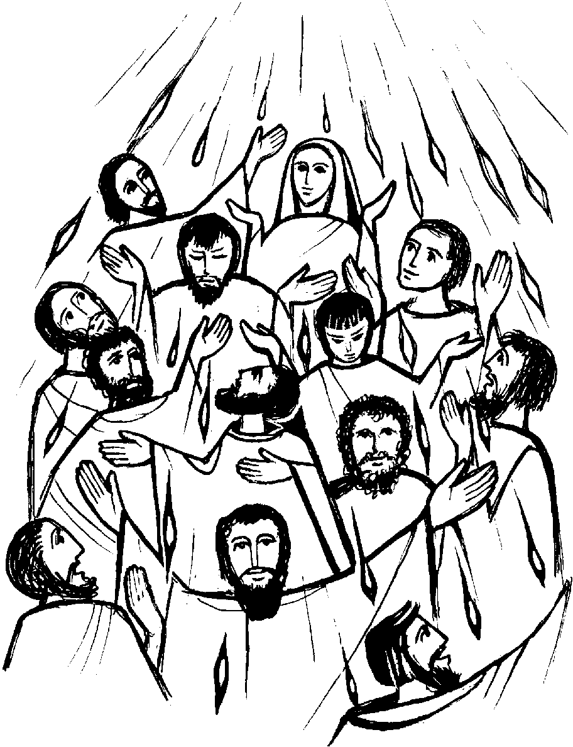
In this topic:
- Some children will begin to talk about how they feel when they have good news to share.
- Some children will begin to say what they wonder about the joy good news brings.
- Some children will begin to talk about how they feel when they hear Good News.
- Some children will begin to say what they wonder about Pentecost Day and the Holy Spirit.

- Some children will begin to recognise the Pentecost story as a religious story.
- Some children will begin to use and recognise religious words such as Pentecost, Good News, alleluia, Easter, Holy Spirit.
- Some children will begin to recognise that Christians are happy at Pentecost and go to church to celebrate the Good News.

