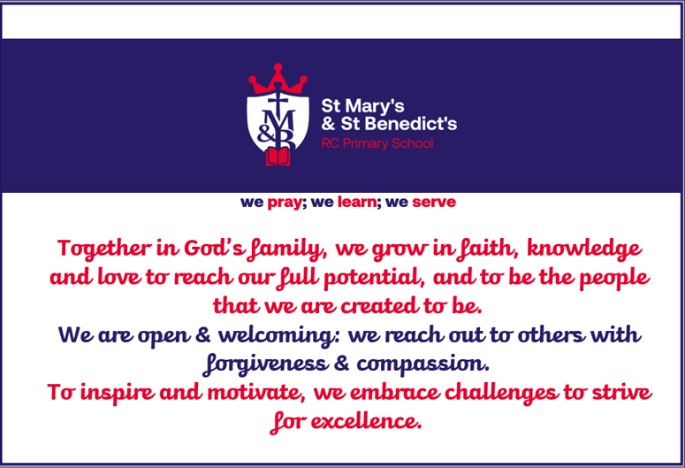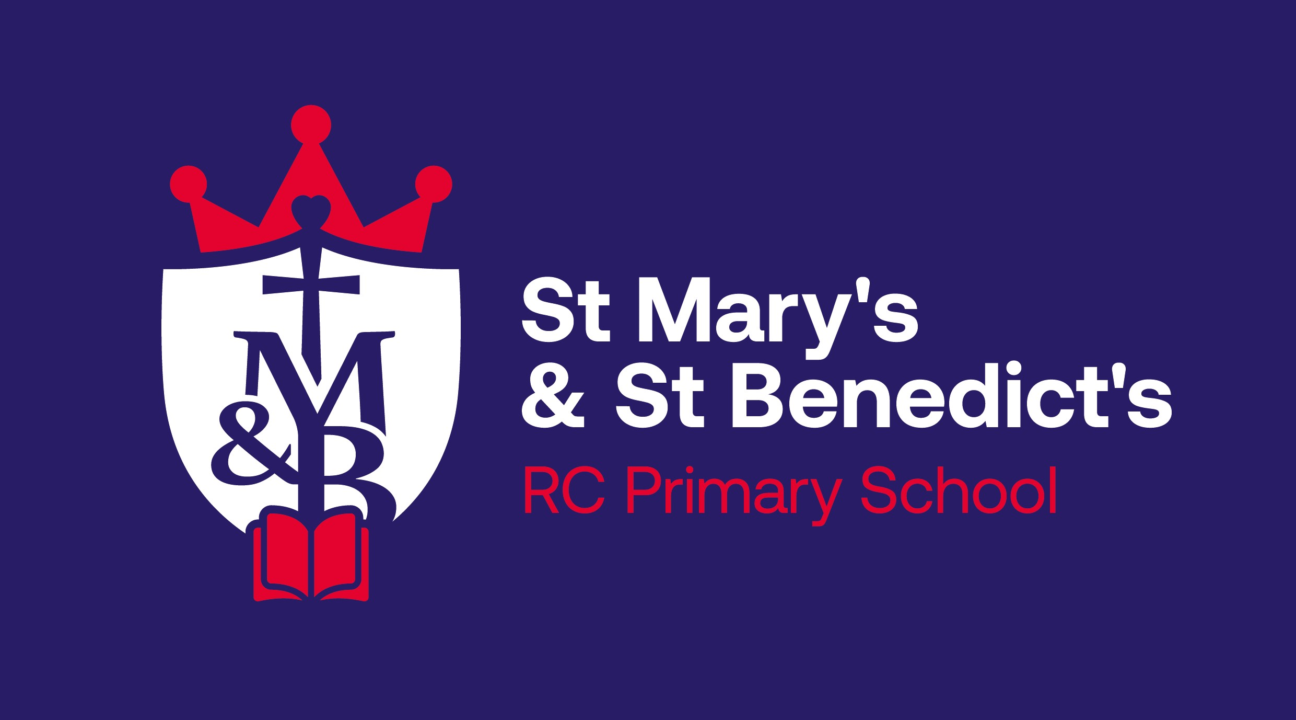
St Mary’s & St Benedict’s RC Primary School PE and Sport Premium 2022-2023
Allocation of Money  (£33,391.00) | Amount | Expected Impact | Professional Development  (Increasing all staff’s confidence, knowledge and skills in teaching PE and sport) | Engaging Least Active  (Increasing engagement of all pupils in regular physical activity and sport) | Curriculum Development  (Raising the Profile of PE and sport across the school, to support whole school improvement) | Achievement of Pupils  (Offer a broader and more equal experience of a range of sports and physical activities to all pupils) | Extra Curricula Activity/ Competitive Opportunities  (Increase participation in competitive sport)
Sports Equipment | £1559.29 | Enough equipment for all children to participate in a wider range of sports and develop their skills. | / | / |  | / | /
Professional PE Coaches | £22, 320.00 | Professional development for staff to increase their confidence, knowledge and skills in teaching sport across the school (EYFS-Y6) and encouraging children to try new activities and sports and raise the profile of PE to all stakeholders. | / | / | / | / | /
Core Swimming | £1021.02 | Ensuring National Curriculum expectations are met and developing children’s water safety skills. | / | / | / | / | /
Swimming (Catch-up from missed swimming due to Covid) | £5032.50 | Ensuring National Curriculum expectations are met and developing children’s water safety skills. | / | / | / | / | /
School Sports’ Competitions | £1000 | Providing children with opportunities to participate in competitions with other schools and raising the profile of PE. | / | / | / | / | /
Taxi (transport to wider opportunities and competitions) | £96 | Providing children with opportunities to participate in competitions with other schools and raising the profile of PE. | / | / | / | / | /

