GEOGRAPHY
POLICY

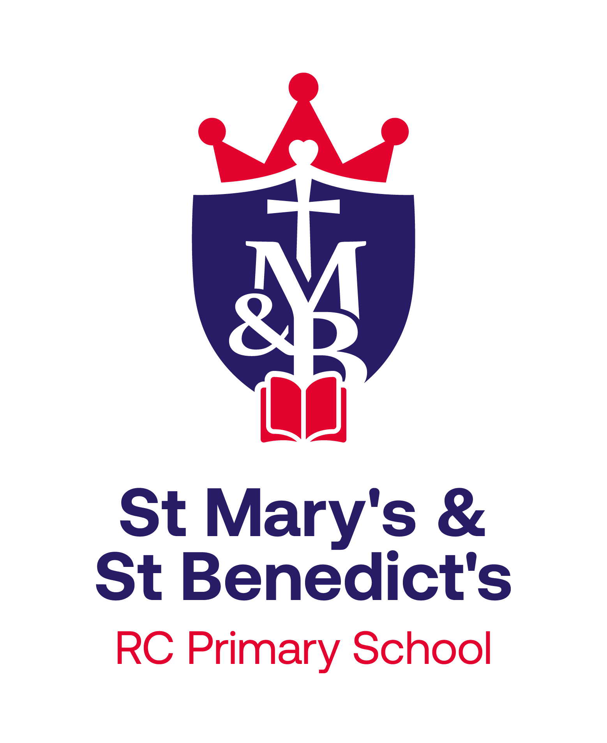

Together in God’s family, we grow in faith, knowledge & love to reach our full potential, and to become the people that we are created to be.

Policy Agreed: February 2023
Review Date: September 2025 (Updated by R Ward.)
Our School Ethos
At St. Mary’s and St. Benedict’s we aim for our curriculum to inspire pupils to be life-long learners with a sense of service to the world that they live in and the people that live in it with them.
We believe our pupils will be life-long learners if they are able to be:
- confident,
- independent,
- curious,
- open-minded,
- enthusiastic,
- observant,
- co-operative and
- resilient individuals.
In order to develop these qualities within our pupils we intend for our curriculum to provide opportunities for children to:
- Be curious and ask questions
- Evaluate and reflect
- Work collaboratively
- Apply their learning
- Solve problems whilst developing resilience
- Communicate their learning
- Challenge ideas
Vision for Geography
At St. Mary’s and St. Benedict’s Primary School, our high-quality Geography curriculum aims to fulfil the requirements of the National Curriculum in an exciting, inclusive and challenging way. We follow the National Curriculum objectives for Geography and have adapted the curriculum to suit our needs as a school.

Geography teaching should equip children with knowledge about diverse places, people, resources and natural and human environments, together with an understanding of the Earth’s key physical and human processes.

We aim to inspire children to think about the wonderfully diverse world in which we live in. The Geography education at our school should inspire in children a curiosity and fascination about the world and its people that will remain with them for the rest of their lives.

Intent
At St. Mary’s and St. Benedict’s Primary School, our high-quality Geography curriculum aims to fulfil the requirements of the National Curriculum in an exciting, inclusive and challenging way. We follow the National Curriculum objectives for Geography and have adapted the curriculum to suit our needs as a school. We have high expectations for our children and we ensure our planning is against Age Related Expectations for each year group. We ensure tasks are appropriately differentiated or adapted to meet the individual needs of our children. Geography teaching should equip children with knowledge about diverse places, people, resources and natural and human environments, together with an understanding of the Earth’s key physical and human processes. The Geography education at our school should inspire in children a curiosity and fascination about the world and its people that will remain with them for the rest of their lives. We encourage visitors to come into the school and inspire children to think of current topics such as climate change, plastic pollution and deforestation.

Implementation
We plan Geography using the Lancashire County Council scheme of work, which we have adapted to suit our needs. As our school has mixed aged classes, we plan Geography on a 2 year cycle to ensure all children have complete coverage of the National Curriculum and have access to the same experiences. We ensure that there are opportunities for children of all abilities to develop their skills and knowledge in each topic and we build planned progression into the scheme of work so that the children are increasingly challenged as they move up through the school. We focus on ‘sticky knowledge’ as children progress through school as we encourage children to recall their prior learning when beginning a new topic. Children record their Geography work, alongside fieldwork in their Topic books. Teachers annotate their plans and use Assessment for Learning methods to ensure all children can access the Geography curriculum at their own level. In Key Stage 1 children develop knowledge about the world, the United Kingdom and their locality. They learn basic subject-specific vocabulary relating to human and physical geography and begin to use geographical skills, including first-hand observation, to enhance their locational awareness. In Key Stage 2 children extend their knowledge and understanding beyond the local area to include the United Kingdom, Europe, North and South America. This includes the location and characteristics of a range of the world’s most significant human and physical features. They develop their use of geographical knowledge, understanding and skills to enhance their locational and place knowledge.

Impact
Assessment for Learning is embedded in Geography lessons and children are active in reviewing the successes in their work and identifying, with support from their teacher, target areas for development.

Work is assessed in line with the Assessment Policies. Key learning is checked at 3 points in the year to ensure children are secure in their Geography knowledge before moving on. Teacher’s formatively assess children’s learning and use Assessment for Learning to move children’s learning forward or redirect learning. We use Assessment for Learning to formatively assess children through their progress in books. We moderate our children’s attainment through conducting ‘Book Looks’ at regular points throughout the academic year. We measure progress through the use of end of topic Teacher assessments. We have recently introduced assessment sheets, which have a series of objectives relating to each unit throughout the year. Teachers use this as a working document and tick off whether a child has met that objective, or partially met it, as the topic is taught. These assessment sheets then inform assessment judgements, as the teachers can objectively look at how many targets have been achieved. Geography is monitored continually from Early Years through to Year 6. We monitor the teaching of Geography through the use of pupil voice, learning walks, book looks and planning checks. Teachers annotate their plans and use Assessment for Learning methods to ensure all children can access the Geography curriculum at their own level.
Marking is in line with the school’s Feedback and Marking Policy.

Our Geography Curriculum
In Key Stage 1 children develop knowledge about the world, the United Kingdom and their locality. They learn basic subject-specific vocabulary relating to human and physical geography and begin to use geographical skills, including first-hand observation, to enhance their locational awareness.

In Key Stage 2 children extend their knowledge and understanding beyond the local area to include the United Kingdom, Europe, North and South America. This includes the location and characteristics of a range of the world’s most significant human and physical features. They develop their use of geographical knowledge, understanding and skills to enhance their locational and place knowledge.

In our Reception class our children work within the Early Years Foundation Stage Framework so Geography is taught through Understanding the World (People and Communities/ The World). Throughout the year, we cover these areas through our topics as children work towards achieving their Early Learning Goals. Children learn about our local neighbourhood, people and places of the world and changes in the seasons.

Concepts

Our Geography curriculum is progressive and knowledge-based. Pupils develop an understanding of key substantive concepts which are revisited throughout their school career. Our chosen Substantive concepts are: Settlements and Land Use; Raw materials, good and trade; Population and Migration; Landforms and how they change; Environments and hot they change and Weather and Climate.

As the children revisit each geographical concept, they build on previously taught learning, making connections and developing their understanding and knowledge of each concept.

When planning each topic, ‘disciplinary concepts’ are planned for, focusing on the specific knowledge and geographical skills relevant to the topic. The disciplinary progression throughout KS1 and KS2 covers Map work, Fieldwork, Compare and Contrast, Observe/ Examine change over time and Similarities and differences. These skills are set out in the Purpose of Study and Aims of the National Curriculum.

Each unit of work is structured around an overarching enquiry question. Each enquiry question is broken down into specific, smaller questions, which create clear, progressive steps throughout the geographical unit. This carefully sequenced learning allows the children to answer the question by the end of the topic.

The use of Knowledge organisers act as a useful source of information for children to refer to during the topic. They contain key vocab, prior learning and useful diagrams or information relevant to the topic. Using their knowledge, vocabulary and geographical skills, the children will work to produce creative outcomes in their Topic books. Their high quality work will reflect the learning planned throughout each topic.

Trips and Visits

Cultural capital is a priority within school. Throughout children’s school career at St. Mary’s and St. Benedict’s, children are provided with a wealth of enrichment opportunities which endeavour to consolidate and deepen their existing geographical knowledge from the classroom. We plan for fieldwork and school trips based around our Geography curriculum to inspire children’s curiosity of the world. Trips and visits include; fieldtrips to Bamber Bridge to complete traffic surveys and identify Physical and Human features, a visit from a local parishioner, who comes into school to share his experiences of Bamber Bridge from his childhood and fieldwork in the school grounds, including the Forest Schools area.

Fieldwork

Fieldwork skills are regularly taught and put into practise at our school, to broaden and deepen children's geographical knowledge.

In Year 3 and 4 this year, we are studying the physical and human features of our local area. We have studied maps at different scales, researched ordnance survey symbols, learnt the 8 points of a compass and done sketches of our school grounds. We recently went on a fieldwork trip into Bamber Bridge to understand the physical and human features of our local area. We used this opportunity to conduct a vehicle survey by timing how many cars went past in 2 minutes. This prompted the children to ask and answer questions about traffic, the time of the day, busy vs quiet periods and what people could be travelling through Bamber Bridge for.

Inclusion within Geography
Provision is made for children with a range of SEND that can be grouped into four broad categories of need, as detailed below:

1. Communication and Interaction

Children and young people in this category have speech, language and communication needs (SLCN) which make it difficult to communicate with others. This may be because they have difficulty saying what they want to, understanding what is being said to them or they do not understand or use social rules of communication.

Children and young people with ASD, including Asperger’s Syndrome and Autism, who are likely to have particular difficulties with social interaction may belong to this category.

2. Cognition and learning
Support for learning difficulties may be required when children and young people learn at a slower pace than their peers, even with appropriate differentiation.
Specific learning difficulties (SpLD), affect one or more specific aspects of learning. This encompasses a range of conditions such as dyslexia, dyscalculia and dyspraxia.
3. Social, emotional and mental health difficulties
Children and young people may experience a wide range of social and emotional difficulties which manifest themselves in many ways. These may include becoming withdrawn or isolated, as well as displaying challenging, disruptive or disturbing behaviour.
Other children and young people may have disorders such as attention deficit disorder, attention deficit hyperactive disorder or attachment disorder.
4. Sensory and/or physical needs
Some children and young people require special educational provision because they have a disability which prevents or hinders them from making use of the educational facilities generally provided. These difficulties can be age related and may fluctuate over time.
Within Geography, like any other subject, we make adaptations to our curriculum to ensure all children can access the curriculum at their level. For example, children can access Dragon Dictation if they are struggling to make their work legible. Children have amendments to their seating arrangement if, for example, they wear a hearing aid. We implement strategies in line with recommendations from external agencies to ensure children approach their work with confidence, for example, using a ‘Must do’, ‘Could do’, ‘Should do’ chart for children who need their work breaking down into manageable chunks.
As a school, St Mary’s & St Benedict’s RC Primary School is committed to ensuring that all children get access to the full curriculum and we will provide suitable amendments to provision to allow this to happen.
At the bottom of this webpage: https://www.smsb.lancs.sch.uk/send/ there is a comprehensive list of subjects and the SEND adaptations that are suggested for each area. Class staff are required to consider these documents to best meet the needs of pupils with identified needs.
English as an Additional Language (EAL)
At St Mary’s & St Benedict’s, we believe that:
• EAL children learn to speak, read and write in English through immersion in a broad, rich curriculum
• EAL learners make the best progress within a whole school context, where children are educated with their peers.
• Bilingualism is viewed as a positive and life-enriching asset.
We work with the EAL team at Lancashire County Council, when deemed appropriate, to access specialist teacher support for pupils. This additional input is co-ordinated between pupil’s class teacher and the SLT lead for EAL provision.
Able, Gifted and Talented (AGT) pupils

At St Mary’s & St Benedict’s, we understand that all children require support and challenge in their learning in order to make progress and reach their potential. Subject leaders work with teachers to identify and support these children through our teaching and learning activities, our more able (MA) pupils are given a wide variety of challenges and experiences which develops their resilience, inspires them and deepens their understanding of the tasks.

They are encouraged to develop their abilities to ask questions, explain and reason, persevere, communicate their thoughts and take risks in their learning. We strive to provide creative means to increase their independence and curiosity, leading to an ever-increasing love of learning.

